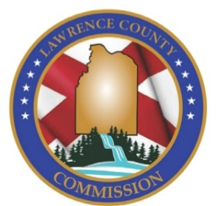
Lawrence County Commission
P.O. Box 307
Moulton, AL 35650
Ph.: 256.974.0663
Fax: 256.974.2403

JOB VACANCY

Lawrence County Commission is Now Accepting Resumes & Applications for the Position of:
TAG CLERK.

Posting: Internal/External
Opening Date: Monday, November 22, 2021
Closing Date: Applications and/or resumes must be postmarked or received by Lawrence County Commission on or before Monday, December 6, 2021 at 4:30.
Job Type: Full Time
Job Location: Lawrence County Revenue Commissioner’s Office, located in the Lawrence County Courthouse

General Job Summary: Responsible for processing and issuing motor vehicle titles and license plates. They will collect cash, issue receipts, balance cash drawer daily, operate computer terminal for tag receipts and input data. He/She should be able to perform reception and referral and general office duties.

Job Requirements:
- High school diploma or equivalent.
- Valid driver’s license.
- Experience in book keeping, math skills to perform basic math application.
- Ability to keep records and make accurate reports.
- Customer service experience is preferred.

Questions can be directed to Lawrence County Commission, 256.974.0663.

Salary Range: Beginning pay $11.25 to $14.38per hour – Salary may be commensurate with experience within the assigned range.
Benefits: Annual Leave, Sick Leave, Health Insurance, Holidays, State Retirement.

**Note: Statements included in this description are intended to reflect general duties & responsibilities of this job & are not to be interpreted as being all inclusive. The employee may be assigned other duties that are not specifically included**

Applications & Resumes can be mailed, emailed or delivered in person to:
By Mail: Email Applications To:
Lawrence County Commission Karen Foster, Payroll Clerk
P.O. Box 307 Subject Line: Assistant Road Foreman Position
Moulton, AL 35650 kfoster@cc.lawrencecountyal.gov

In Person Delivery:
Lawrence County Commission
12001 Al. Hwy. 157
Annex 3 Suite 1
Moulton, AL 35650
**For full job description you may request one in person or by phone at 256.974.0663**
**Must pass a pre-employment/post offer drug screen**

****Lawrence County Commission is a drug free equal opportunity employer****

