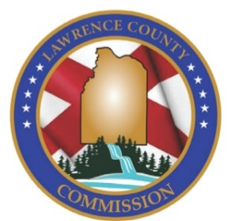
Lawrence County Commission
P.O. Box 307
Moulton, AL 35650
Ph.: 256.974.0663
Fax: 256.974.2403

JOB POSTING

Lawrence County Commission is Now Accepting Resumes & Applications for the Position of:
LAWRENCE COUNTY SOLID WASTE – Heavy Equipment Mechanic

Posting: Internal/External
Opening Date: Monday, November 8, 2021
Closing Date: Applications and/or resumes must be postmarked or received by Lawrence County Commission on or before Monday, November 22, 2021 at 4:30.
Job Type: Full Time
Job Location: Lawrence County Solid Waste, 680 Gordon Drive, Moulton, AL 35650

General Job Summary: Performs automotive, garbage truck, and diesel repair and maintenance. Welds metal parts as specified. Maintains county shop as well as all shop equipment and tools used. Receives general instruction from Lawrence County Solid Waste Director and Lawrence County Sheriff.

Job Requirements:
- High school diploma or equivalent.
- Valid driver’s license.
- Experience in automotive repair, diesel repair and maintenance required.

Questions can be directed to Angela Baldwin, Solid Waste Director, 256.974.2573

Salary Range: Beginning pay $21.14 to $27.05 per hour – Salary may be commensurate with experience within the assigned range.
Benefits: Annual Leave, Sick Leave, Health Insurance, Holidays, State Retirement.

**Note: Statements included in this description are intended to reflect general duties & responsibilities of this job & are not to be interpreted as being all inclusive. The employee may be assigned other duties that are not specifically included**

Applications & Resumes can be mailed, emailed or delivered in person to:
By Mail: Email Applications To:
Lawrence County Commission Karen Foster, Payroll Clerk
P.O. Box 307 Subject Line: Assistant Road Foreman Position
Moulton, AL 35650 kfoster@cc.lawrencecountyal.gov

In Person Delivery:
Lawrence County Commission
12001 Al. Hwy. 157
Annex 3 Suite 1
Moulton, AL 35650

**For full job description you may request one in person or by phone at 256.974.0663**
**Must pass a pre-employment/post offer drug screen**

****Lawrence County Commission is a drug free equal opportunity employer****

